Appium Test Automation
Architectural Design

Created: June 17th, 2025
Author: Mohamed Riza Mohamed Razik

Introduction
This architectural document provides a detailed in-depth of the Appium Test Automation design and implementation methodology.

Scope of work
The scope of this project is to automation the ABC mobile application using the below technology and tools.

Testing Types:
Below test types and test suites will be developed as part of this project.

Functional Test Automation Suite
A functional test automation suite will be developed to test all the components of the mobile application.

Regression Testing Automation Suite
A Regression test automation suite will provide a subset of the functional test suite that will be used to execute on a periodical manner and/or after every product deployment to identify any breakages.

Smoke Test Automation Suite
A smoke test automation suite will be used as part of CI/CD pipelines to be executed after every code deployment for this product in all environments such as QA, UAT, Production. This will ensure the critical functionalities are not broken as part of the new changes deployed.

High Level Appium Architectural Design

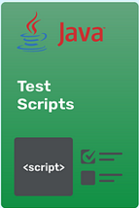






Appium HTTP Server
Appium Client

Mobile Devices and Platform

Appium Client: This is where the client automation code (Java / Selenium) will be developed. Appium supports several programming languages such as Java, C#, Python, etc.
Appium HTTP Server: The client code will be converted to JSON and communicate with the Appium server to perform actions on the mobile devices.
Mobile Devices: These could be virtual devices used for testing purpose only or actual devices connected and tested through.

Sample code implementing Appium Tests
Below is a sample Java code snippet created to open the calculator app in the mobile device.

Initialize the Appium Wed Driver
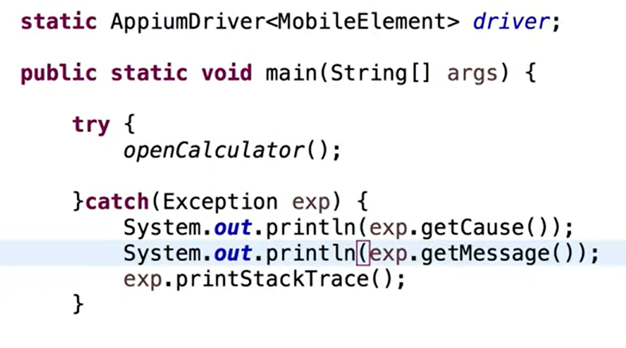
Configure the device, Appium server URL, and open the calculator app on the device.
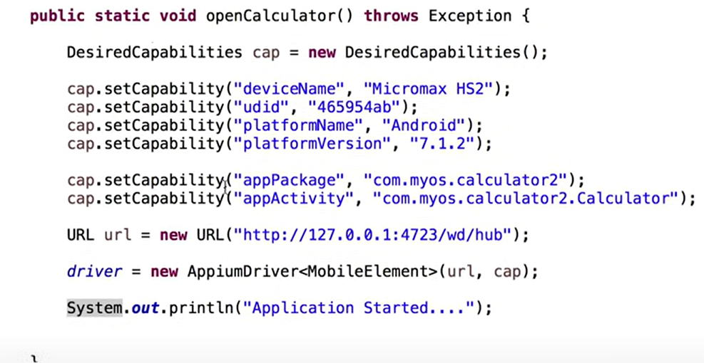

Tools Used

IDE: Intellij
Programming Language: java
Libraries: Selenium, TestNG, Cucumber, and other libraries required to run these tests
Framework: Appium

Appium Framework
Appium is a cross-platform testing framework that is flexible, enabling testers to write test scripts against multiple platforms such as iOS, Windows, and Android using the same API. That means the QA can use the same code for iOS as for Android, that will save time and effort and reduce redundant work.

Implementation:
- The Appium framework bridges a test script and a mobile application running on a physical device or an emulator/simulator.

- The Appium Server accepts the commands from the test script via the REST API and uses WebDriver to convert them into the appropriate automation actions for the mobile platform.

- The Test Cases will be developed using Java and Selenium. IntelliJ will be used as the IDE (integrated Development Environment) to develop the test suite.

BDD (Behavior-driver Development)
- BDD is a simple file that is used to write the test cases step by step using simple English language using certain key words such as “Given”, “When”, “Then”, “And” (Gherkin Language).

- These files are also used as the requirements and can be understood by all stakeholders involved in the project. These files are called Feature files.

- These test cases are then linked to the Java code to be executed in the mobile devices.

Reusability and Maintenance
- Reusability in automation testing refers to the ability to use and leverage existing test assets, such as test scripts, test data, and test frameworks, across different testing scenarios or projects.

- It allows testers to save time and effort by avoiding redundant work and promotes efficiency in the testing process.

- Reusable functions are developed that will perform a certain action using dynamic input parameters. These functions can be reused throughout multiple test cases by avoiding the tester to develop them again.

- BDD makes reusability even more robust as the steps created in the feature files can be simply used in another feature file as desired and it should simply work.

Overall Project Design
Below is the detailed steps to be performed from the project start till sign-off and closure.

